Computer Language Coding Concepts

Command References in an Active Clause in a Diagram
Command references in an active clause have been conceptually explained in the article Command References in an Active Clause.

This article only illustrates how command references in an active clause look in a diagram.

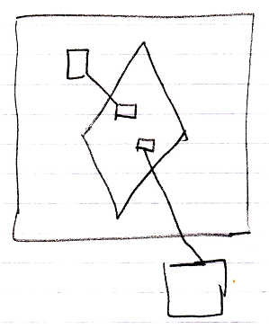

The large square is the command definition, that the active clause is in. The diamond is the active clause. The smaller squares inside the diamond are command references in an active clause. They are actually public command references. This makes the command references parameters of the active clause. The command references have object lines, solid ones, going outside, ending at the targets of the command references.

The creation behavior of command references in an active clause will not be further explained with diagrams in this article. Refer to the article Creation Behavior of Command Callls in a Diagram for an illustration of how the creation behavior of command calls looks in a diagram.

See also: Command References in an Active Clause,
Creation Behavior of Command Calls in a Diagram

Author & Copyright: Jan-Joost van Zon Date: August 9, 2008 – August 9, 2008 Location: Oosterhout, The Netherlands Status: Finished

